Algebra 1: Unit 7, Lesson 3

- The area model for $x^{2}-7x+12$ is shown. Complete the table.
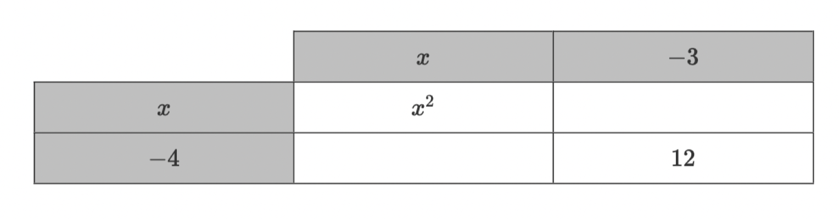
$$-3x$$
$$-4x$$

- Find $g$and $h$ when $g<h$, $g⋅h=-21$, and $g+h=4$.

$g=-3$ and $h=7$

- An expression is shown.
$$16x^{6}-8x^{4}$$Write the equivalent expression using the greatest common monomial factor.
$$8x^{4}(2x^{2}-1)$$

